IV Moscow Youth International Model Arctic Council (MAC-2019)
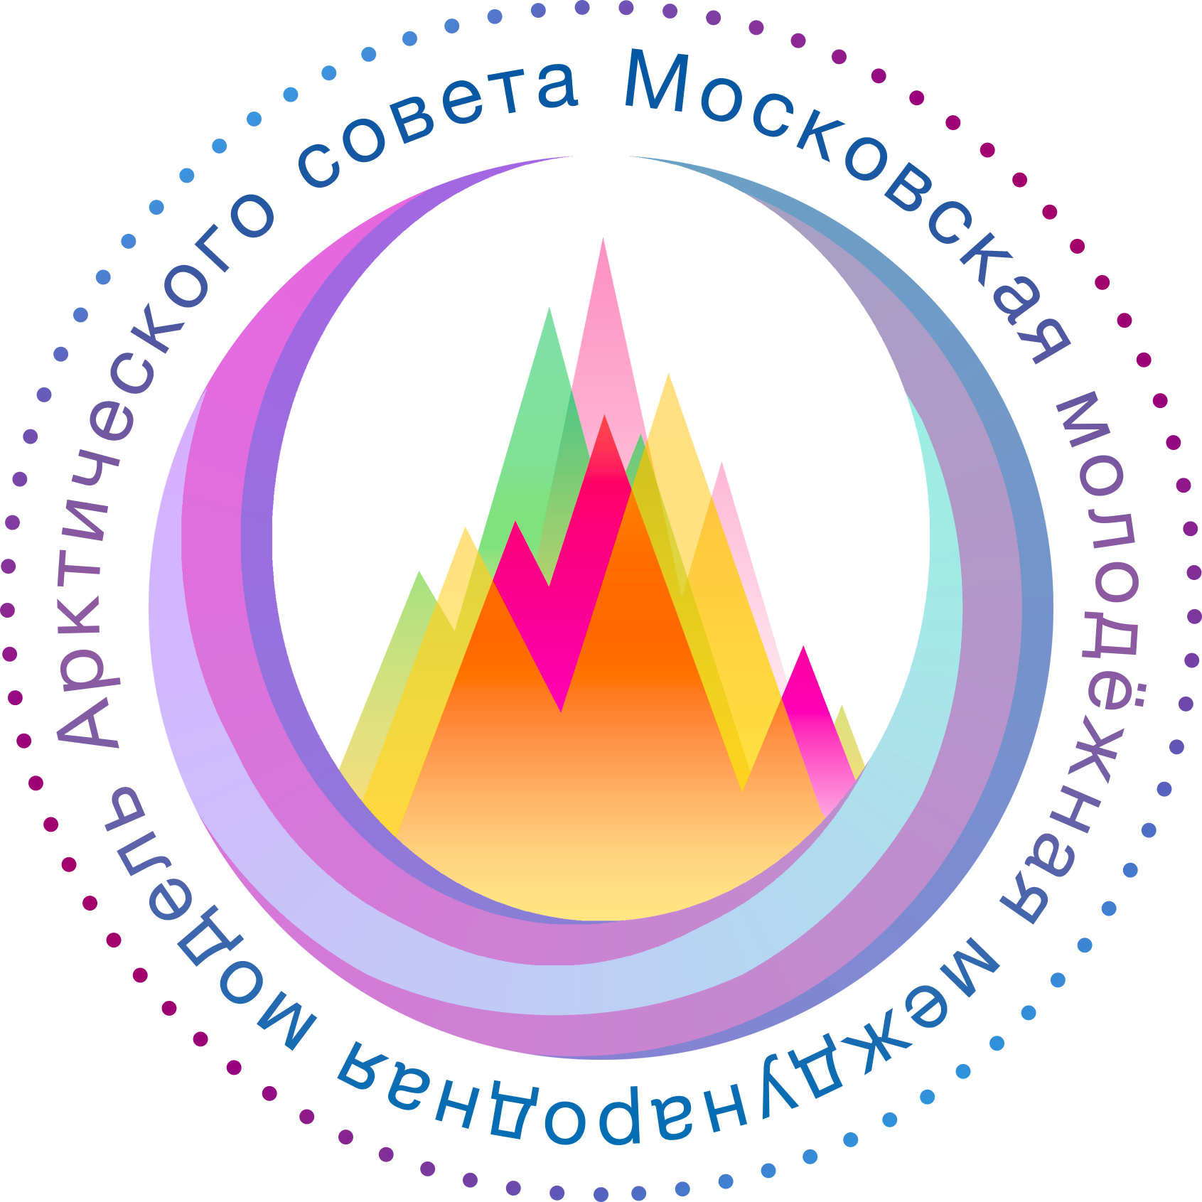

MOSCOW DECLARATION 2019

Arctic Council
Sustainable International Shipping and Protection of Marine Environment

Moscow, Russia December 9-10, 2019
MOSCOW DECLRATION 2019
On the occasion of the Fourth Moscow Youth International Model Arctic Council (MAC-2019)
We, the Ministers representing the eight Arctic States, joined by the representatives of the six Permanent Participant organizations, have gathered in Moscow, Russia, at the conclusion of the Fourth Moscow Youth International Model Arctic Council (MAC-2019),
Reaffirming the commitment to maintain peace, stability, and constructive cooperation in the Arctic,
Affirming the Arctic states’ commitment to further strengthen the Arctic Council and its activities,
Reaffirming our commitment to the well-being of the inhabitants of the Arctic, to sustainable development and to the protection of the Arctic environment,
Recognizing the rights of Arctic Indigenous peoples and the unique role of the Permanent Participants within the Arctic Council, as well as the commitment to consult and cooperate in good faith with Arctic Indigenous peoples and to support their meaningful engagement in Arctic Council activities and policy shaping,
Acknowledging the contributions of local authorities, and the interests of all Arctic residents and communities in the work of the Arctic Council,
Acknowledging the contributions of non-Arctic states, other permanent and ad hoc observers,
Taking into account the traditional knowledge of indigenous peoples,
Noting with concern that the Arctic is warming at more than twice the rate of the global average, resulting in widespread social, environmental, and economic impacts in the Arctic and worldwide, and the pressing and increasing need for mitigation and adaptation actions and to strengthen resilience,
Acknowledging that Arctic marine ecosystems are under increasing pressure from multiple stressors including ocean warming and acidification, long-range pollution and increased human activities.

HEREBY:
PROTECTION OF ARCTIC MARINE ENVIRONMENT
- Preserve common commitment to reduce plastic waste and microplastics,
- Welcome the increase of the Polar Research Budgets for funding small-scale scientific projects of the Arctic and non-Arctic states (The Netherlands),
- Support the work related to climate change adaptation and livelihoods,
- Look forward to deepening work on Oceans and related to PAME (Protection of the Arctic Marine Environment) and TFAMC (Task Force on Arctic Marine Cooperation) task forces,(UNDP)
- Involve residents in such activities and engaging meaningfully with them is an ongoing process that builds a foundation on which problems can be solved or managed, (RAIPON)
- Define an appropriate division of measures both internally among their own programmatic activities and externally in their relations with other bodies endeavoring to promote cooperation in the circumpolar north (AAC),
- Adapt and improve the way in which it does business if it is to further increase its credibility and influence nationally and internationally,
- Consider the case for amending the UNFCCC to embed the concept of the Arctic-as-global-climate-change-barometer, (AAC)
- Support of the commitment of the Kiruna Declaration to "increase cooperation and interaction with the business community" by establishing a "Task Force to facilitate the creation of a circumpolar business, (AAC)
- Pursue research to understand the physical processes in the atmosphere, the ocean, and sea ice through field observations of key areas in the Arctic Sea and satellite remote sensing and develop a model to increase understanding and interaction, (South Korea)
- Propose to conduct Research on Climate Change Forecast Using Arctic Science Infrastructure, develop data assimilation technology for marine and sea ice data in the Arctic Sea, create new joint research programs on Arctic climate change, (SK)
- Ensure sustainable use and conservation of Arctic marine resources, (Canada)
- Keep preserving the ecological balance in the marine, ice and land areas of the unique environment,
- Prioritize sustainable use of the resources in the Arctic marine environment, (Canada)
- Stay committed to develop the Framework for a Pan-Arctic Network of Marine Protected Areas which suggests an ecologically connected, representative and effectively managed network of protected areas and specially managed areas that protects and promotes the resilience of the biological diversity, ecological processes and cultural heritage of the Arctic marine environment, and the social and economic benefits they provide to present and future generations,
- Join the ACOPS network of internationally recognized specialists who cover important topics such as law of the sea, marine policy developments, fisheries management, oceanography, pollution research and control, marine mining and offshore and coastal mining (including deep sea mining), marine biology and ecology,
- Continue cooperation within the agenda with the Office of the London Convention and London Protocol and the OSPAR Commission (the Regional Seas Convention for the Protection of the Marine Environment of the North-East Atlantic) on the international regulation of ocean fertilization, marine geo-engineering, carbon sequestration and aspects related to the disposal of sediments, wastes and other effluents from deep-sea mining in particular and waste disposal at sea generally, with a focus in particular on marine litter, deep-sea tailings placement and marine spatial planning, (ACOPS)
- Continue following the work of the International Seabed Authority (ISA),
- Support the Universities and research institutions in the Arctic and non-Arctic states that spread comprehensive Arctic studies amoung student and young researchers.

SUSTAINABLE INTERNATIONAL SHIPPING IN THE ARCTIC
- Remain committed to follow the the Maritime and International Law conventions and the International Maritime Organization’s Polar Code, adopted in 2017, (Spain, Norway, Faroe Islands, AAC)
- Believe that only on compliance with international law we can preserve the cooperative and environmentally friendly character of international shipping and economic activities in the Arctic, (Spain)
- Commit ourselves to foster sustainable shipping in the region by means, among others, of the provision of nuclear icebreakers and the design of icebreaker lasers, (Russia)
- Deem cooperation vital in order to attain such development along with the security of the region, (Russia, Sweden and Norway)
- Acknowledge the importance to be resourceful when it comes to emergency preparedness, and this depends on tighter monitoring and regulation capable of responding to distress situations, (USA)
- Propose that all members engage in an overall training of officers and find common measures towards the improvement of infrastructure so that we can achieve a safe navigation, (Russia)
- Encourage to continue to boost the quality of life of indigenous population in the Arctic thanks to the modernization of the transport system, namely shipping, which is both based on the transport and supply of green energy, (Russia)
- Support the measures such as investments in developing and implying new technologies in shipbuilding industry based on alternative fuels and/or clean energy sources, which (we hope) will allow us to transfer cargo safer and faster, (Greenland, the Faroe Islands, South Korea)
- Agree to set up national safety standards for polar ships and evelop technology for safe navigation of ice class ships along polar routes and relevant testing technology, in compliance with the Polar Code,
- Share open data of damages and incidents in the Arctic region, (SC)
- Suggest to conduct a special research on microplastics caused by shipping activities,
- Suggest to conduct a special research on the impact of arctic investment, construction and modernization of shipping to the quality of life of the indigenous people,
- Recommend to join the project of the Memorandum of Understanding under the auspices of the IMO regarding the commitment of the Arctic and non-Arctic states to follow the Polar Code, (IMO)
- Appreciate that Norway has created a template and invited each Arctic State and each Observer State to submit information on how it understands and applies in practice the IMO Polar Code,
- Agree to mitigate the risks associated with the the use and carriage of HFO by ships in Arctic waters,
- Welcome the Iceland’s and Finland’s project titled “Black carbon emissions concerning shipping activity in the Arctic and technology development for their reduction”, especially because countries take into account relevant developments at IMOs Sub-Committee on Pollution Prevention and Response (PPR) 6th Session and IMOs Sub-Committee on Marine Environment Protection Committee (MEPC) 74th Session,
- Establish new comprehensive pollution prevention standards, to strengthen the safety and reliability of marine transport in the Arctic (Canada), hereby intensify the work of the Arctic Council working groups and task forces in that context.
ADAPTATION OF THE ARCTIC SEA ROUTES TO THE CHANGING MIGRATION ROUTES OF ARCTIC MARINE ANIMALS
- Note that navigation routes should not cross the migration routes of marine species, in order not to harm these animals, (Greenland)
- Agree that in areas where migration routes of marine animals with special conservation status ("endangered") are taking place, navigation should be restricted during the migration of these animal species,
- Suggest creating a working group on a permanent basis, which will make a more detailed map of changes in the migration of Arctic marine animals. To entrust this working group with the responsibility for: constant monitoring of trends in migration routes and their mapping, as well as providing companies (organizations) with recommendations on how to adapt their navigation routes in the best way, (Greenland)
- Support the initiative to help all companies (organisations) whose vessels sail in the Arctic to define and adapt their navigation routes to changes in the migration routes of Arctic marine animals (Greenland)
- Encourage the promotion of technological improvements to mitigate the sound disturbance to which the whales in particular are sensitive.
THEREFORE, we the undersigned representatives of our respective Governments, recognizing the Arctic Council's political significance and intending to promote its results, have signed this Declaration.
Signed by Representatives of the Arctic Council on the 10th Day of December, 2019 in Moscow, Russia:

FOR THE GOVERNMENT OF CANADA

FOR THE GOVERNMENT OF FINLAND

FOR THE GOVERNMENT OF NORWAY

FOR THE GOVERNMENT OF SWEDEN
FOR THE GOVERNMENT OF DENMARK

FOR THE GOVERNMENT OF ICELAND

FOR THE GOVERNMENT OF THE RUSSIAN FEDERATION

FOR THE GOVERNMENT OF THE UNITED STATES OF AMERICA

ANNEX

